“PaperHub”
M. Haseeb - L1S23BSCS0336
Ali Hamza - L1S23BSCS0321
Faisal Khalid - L1F23BSCS0192
Phase II
User Research & Validation
- What did you learn from talking to users?
- Users are frustrated related to Past papers
- They keep asking for past papers as it can be studied from real data.
- How did user feedback change your solution design?
First we decided to design the navigation system of 4 screens as:
Department_Screen Program_Screen Subject_Screen Past_Papers
We will use Async Storage to save user’s Department and program. It will reduce 4 screens to 2 screens only and contribute to the better UX.
Subject_Screen Past_Papers
3. Which assumptions on your understanding of the problem were validated /disproved?
Validated | Disapproved
Students need past papers | Students will use this website every day. But the survey shows that students only use it near exams.
Past papers are scattered and need a unified platform for arrangement. | We thought that students will prefer online view but the survey shows that they prefer downloaded pdf.
We used Machine Learning to analyze the data of 1000+ students from UCP official group
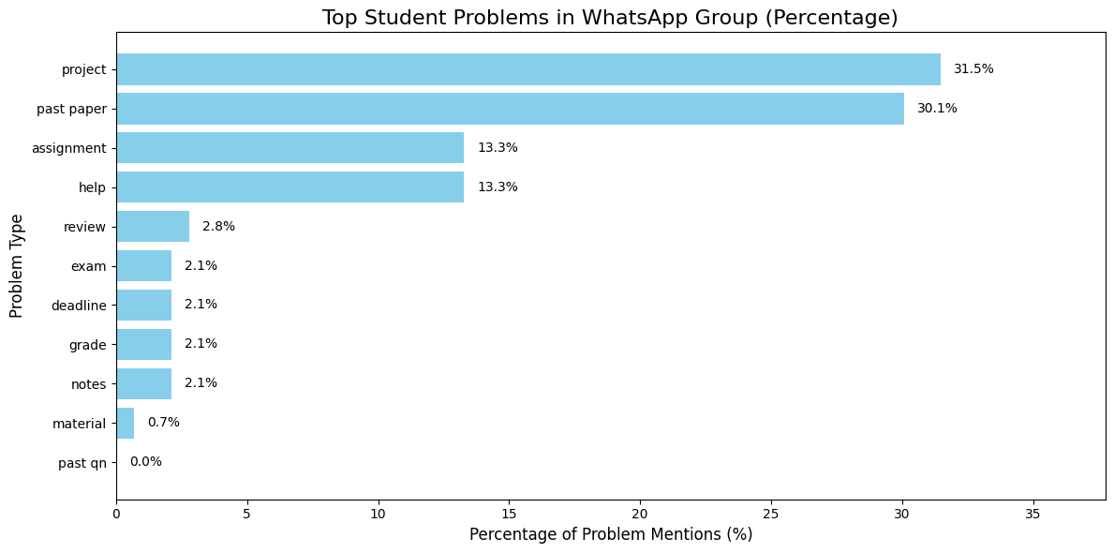
Data Source: WhatsApp Chat with FOIT ~ CS Department - Ext 1.txt
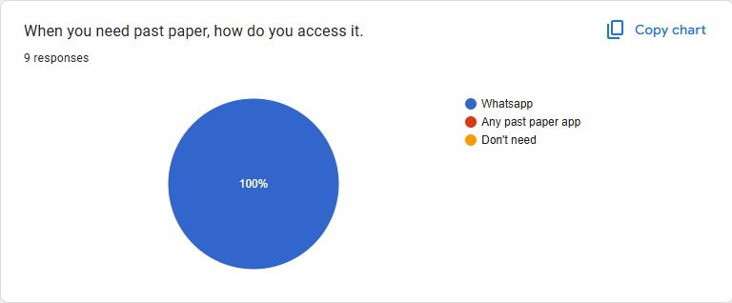
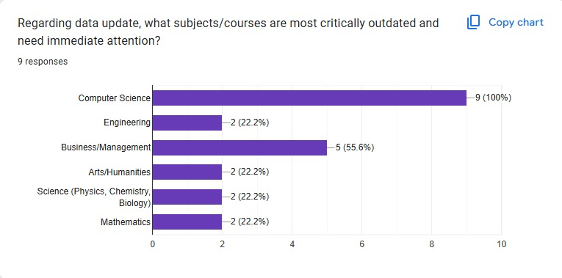-Survey results

MVP Scope & Features
- What core features will be included in the MVP?
- Mids
- Finals
- Quizzes
- Assignments
All this material will be accessible within the single website.
- Which features are out of scope for this hackathon?
As we are making an MVP therefore we are neglecting the following
- rating for the past papers.
- Reviews of Students

3. How will your MVP demonstrate value to users?
PaperHub will provide an easy access to the students for downloading the past papers. The MVP will show how a student can find a specific paper in under 30 seconds, compared to scrolling through weeks of WhatsApp messages.

Implementation & Technical Planning

- Which technical tools, platforms, or languages will you use?
Component | languages | Why do we choose this
Frontend | React.js with Tailwind CSS | They are modern and easy languages.
Backend | Node.js with Express.js | Lightweight
Database | Supabase or Firebase | Easy to deploy
Deployment | Vercel | You can deploy your site directly from a GitHub repository in minutes.

- How will you prioritize features for Day 2 development?
• High Priority: Database structure (Department -> Subject -> File) and the search function.
• Medium Priority: Beautiful UI.

- What challenges do you anticipate, and how will you address them?

Data entry and Data Collection is the biggest problem. We will address this by focusing on one department first FOIT as a proof of concept rather than trying to fill the library for the whole university in 2 days.

